1.Introduction
This project focuses on analyzing loan data to identify high-risk customers. The dataset contains 252,000 records with customer details such as income, age, profession, and risk flag. The objective is to understand patterns that influence loan default risk.
2. Objective
- To analyze customer risk patterns
- To identify high-risk groups
- To support loan approval decision-making
3. Dataset Description
- Total Records: 252,000
- Total Columns: 13
- No missing values found
Columns:
- Income
- Age
- Experience
- Marital Status
- House Ownership
- Car Ownership
- Profession
- City
- State
- Current Job Years
- Current House Years
- Risk Flag

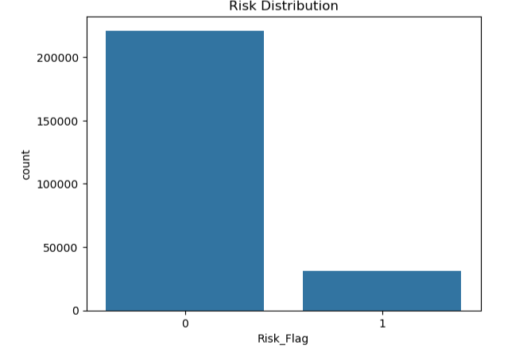
1.Risk Distribution
Insights:
Most customers are classified as low risk, with a smaller proportion identified as high risk. This indicates an imbalanced dataset.
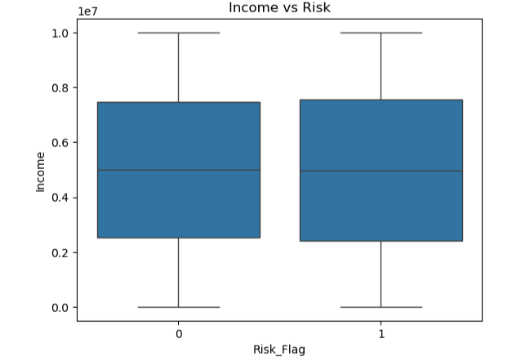
2.Income vs Risk
Insights:
Income does not show a strong distinction between risky and safe customers, indicating that income alone is not a key predictor of risk.
3.Age vs Risk
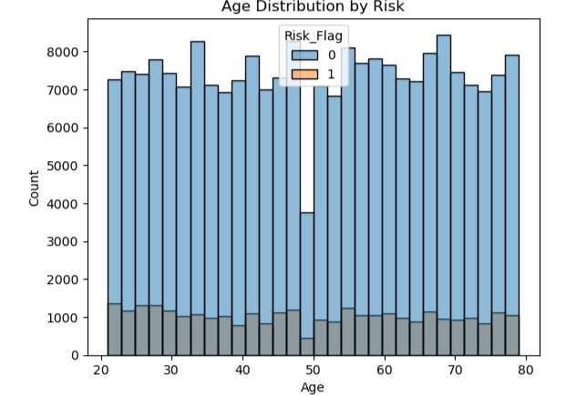
Insights:
Risk is distributed across all age groups, suggesting age is not a dominant factor in predicting loan default.

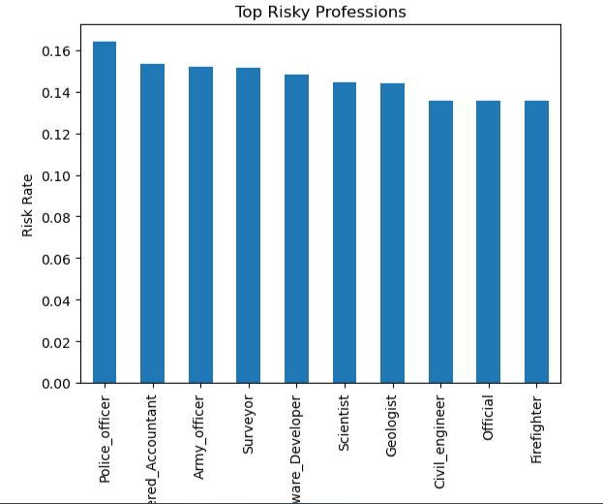
4.Profession vs Risk
Insights:
Certain professions show higher risk levels, indicating that occupation plays a role in determining loan default probability.
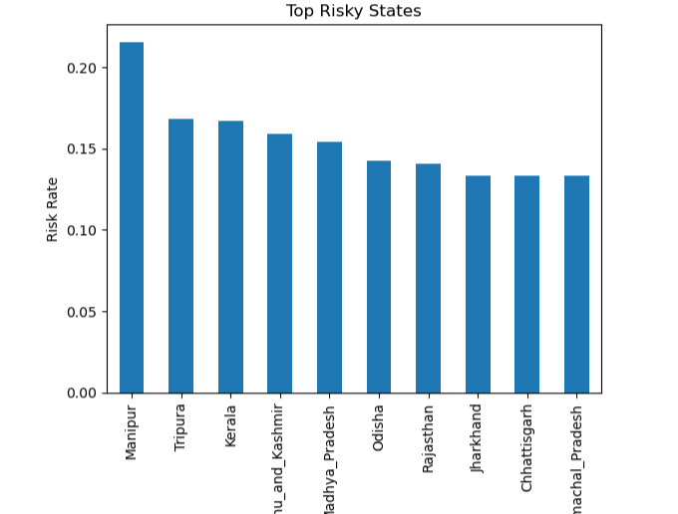
5.State vs Risk
Insights:
Risk levels vary by state, suggesting geographic factors influence loan default behavior.

